Wellington Free Kindergarten Association

Some early kindergarten books

Helen May, Emeritus Professor University of Otago

March 2019

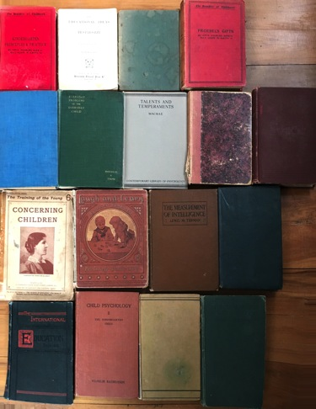 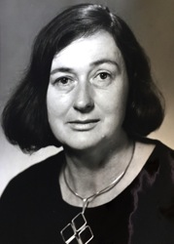

Geraldine McDonald 1925-2018

After 45 years of careful custodianship in the home of Dr Geraldine McDonald, 18 books that were originally in the library of the Wellington Free Kindergarten Association’s Kindergarten Training College are currently in my custodial home. Geraldine died in November 2018, and I am currently working with her daughters, Mandy McDonald and Caroline McDonald, to sort her academic papers. There is an interesting back-story to why Geraldine was given these books for safekeeping. My own custodianship will be shorter which is why I am writing this brief story. Three possibilities for the future of this precious remnant of a kindergarten library come to mind:

* Reuniting the collection with the Wellington Free Kindergarten Association’s archives held in the Alexander Turnbull Library.
* Keeping the collection with some of Geraldine’s books and publications, perhaps in a display cabinet at the Faculty of Education at Victoria University, now incorporating what was the Kindergarten Training College and the Wellington College of Education: all places where Geraldine worked at various times. Linking this collection with the oil portrait of the last Principal of the Kindergarten Training College, Miss Joyce Barns, gifted to the Institute of Early Childhood Studies would be an idea.
* Returning the collection to He Whāaau Manaaki o Tararua - what is now an expanded Wellington Regional Kindergarten Association, to rest alongside the table and chair that was once in the office of Miss Joyce Barns. This was gifted to the Wellington Free Kindergarten Association on her retirement.

We welcome advice on what might be appropriate.

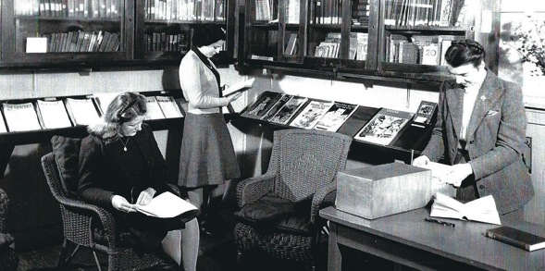

WFKA library at the Taranaki Street Kindergarten Colleg, late 1940s.

In 1975 the four kindergarten associations that offered a two year kindergarten course, certificated by the NZ Free Kindergarten Union, were merged into four teacher training colleges: Wellington, Christchurch, Auckland and Dunedin. This was not a happy move, partly because the kindergarteners thought they were getting the equivalent three-year qualification of primary teachers but at the last moment were told that the two-year qualification would remain. An excerpt below is taken from a description of the process published in, *Growing a Kindergarten Movement in NZ* (May & Bethell, NZCER Press, 2017).

There were issues around the lack of consultation from the Department of Education with NZFKU, the kindergarten teaching staff, and the KTA. The significant tension was around the transfer of kindergarten staff, the number of staff ‘wanted’ by the colleges, and their status. Treasury initially refused to appoint early childhood senior lecturers, and when a salary scale including senior position was negotiated it was deemed to ‘denigrate’ the status of kindergarten. The transfer was made in 1975 with considerable disarray, and stories abounded for years about the hurt of those concerned.[1] …Anne Meade summed up the mood: “Many kindergarten people said it should have been a happy occasion, but the rush and the lack of consideration for the people involved took the edge off the pleasure.”[2]

In 1964 Geraldine had held the position of Assistant Principal at the Wellington Kindergarten Teachers’ College. Prior to the transfer Geraldine was lecturing both at Wellington Teachers’ College and the Kindergarten Teachers’ College until 1974 when she took up a position at the NZ Council for Educational Research. In 1975 NZCER published the illustrated booklet *An Early Wellington Kindergarten;* a story compiled by Geraldine based on Edna [Ted] Scott’s thirty-year experience as a kindergartener at Taranaki Street Kindergarten.

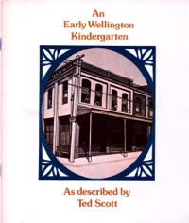 Compiled by Geraldine McDonald, NZCER 1975.

In preparation, Geraldine had gathered reminiscences, photographs and historical data with the assistance of Joyce Barns, Principal of the college. A few documents have been found in Geraldine’s papers and will be used in Kerry Bethell’s forthcoming chapter, ‘Further encounters with *An Early Wellington Kindergarten*’ in the book, *Improving The Lives Of Women And Children: A tribute to Dr Geraldine McDonald*  (Middleton & May, eds. NZCER Press). Mandy McDonald remembers her mother enjoying working on the booklet and being particular pleased with its production and the cover.

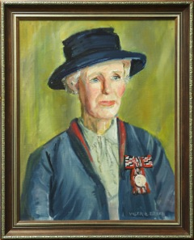

Joyce Barns, an oil painting by

Valerie Beers, Institute of

Early Childhood Studies, Victoria

University Wellington

Joyce Barnes retired prior to the transfer to the Karori campus from the Kindergarten College, by then located in The Glen in Kelburn. Joyce was aware that her lack of university qualifications would be an impediment to winning a position. She was personally very hurt by the process and concerned with the disarray of the transfer, which meant shifting all the resources, including the library, to the Karori campus. At this point Joyce handed to Geraldine the collection of books for safekeeping as well as four sets of Froebel blocks. Joyce would have appreciated Geraldine’s interest and knowledge of kindergarten history. The blocks were made by Milton and Bradley in the US, probably in the early 20th century, and probably for Mary Richmond for the Richmond Kindergartens established in 1905 was renamed the Wellington Free Kindergarten Association in 1914. Froebel blocks were phased out of use in kindergartens in the early decades of the 20th century when most got lost or in the case of the college, were kept for historical interest. Geraldine later gave the blocks to the Museum of NZ Te Papa Tongarewa where they have sometimes been on display. Gift 3 had previously been photographed by NZCER for inclusion in *An Early Wellington Kindergarten.*

 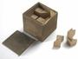 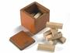 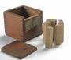

Froebel Gifts 3, 4, 5, 6, [GH004084 [86, 87, 89, 90]

It is unlikely that either the blocks or the books would have otherwise survived the transfer. I have found no remaining collection of artefacts or books from the kindergarten college at Wellington College of Education; later merged and relocated to Victoria University city campus. The mainly reference books are from the late 19th and early 20th century. Some of the books would also have been in the Wellington Teachers College Library, which in earlier years did cover kindergarten practice, and maybe that is why Joyce did not transfer them. Some of the books, however, were still in use and cited the names of borrowers on issue cards still inside back cover pockets including, ‘Geraldine McDonald’ who borrowed: *Froebel’s Gifts* (1896) by Kate Douglas Wiggin & Nora A. Smith on 5 November 1973. This was undoubtedly useful in the preparation of *An Early Wellington Kindergarten.* Several other books were labelled as ‘staff library’. Geraldine told me about the collection in the 1990s although I have only now sighted the books as we start to sort Geraldine’s library. Mandy and Caroline, were made aware by Geraldine that the books were regarded as ‘valuable’ but did not know how their mother had acquired them.

**Catalogue**

Susan S. Brierley (1921, 4th ed. 1928) *An Introduction to Psychology* (with a new preface by Susan Isaacs)

[Stamped ‘Wellington Free Kindergarten Association’. Last issued to ‘S. Brown. 30 July ??’]

James H. Fassett, *The New Beacon Readers. Dominion Edition, Book Four,* London, Ginn and Company Ltd.

[Stamped ‘Wellington Free Kindergarten Association’. Once belonged to Keith Bentley P3, who has also written is name in pencil. No issues on library card]

Charlotte Perkins Gilman (1907) *The Training of the Young: Concerning Children, London, Watts & Co.*

J. A. Green (1907) *The Educational Ideas of Pestalozzi,* London, University Tutorial Lane. [Cover missing]

William T. Harris (ed.) (1911) *The Mottoes and Commentaries of Friedrich Froebels’s Mother Play,*  New York & London, D. Appleton & Co.

[Stamped ‘Wellington Free Kindergarten’. Last issued ‘L. Northe, 5 August ?? and previously to ‘Ruth Beaglehole 30 Nov. ??’]

Jennett Humphreys (1890) *Laugh and Learn: The easiest book of nursery lesson and nursery games. Profusely Illustrated,* London, Blackie & Sons Ltd.

[Signed ‘S. M. Brockett 1985’]

Mary Lush (1926) *Progressive Kindergarten Methods,*  Melbourne & Sydney, Lothian Publishing Co. Pty. Ltd.

[Covered, Stamped ‘Wellington Free Kindergarten Association’. Last issued ‘Greta Buchler, 25 May 1955’]

Angus Macrae (1932) *Talents and Temperaments*, London, Nisbet & Co. Ltd.

[Signed in pencil, ‘J. Sharpe, 104 Tinakori Rd]

Percy Nunn (1920, 3rd 3ed. 1945) *Education its Data and its First Principles,* London, Arnold.

[Stamped Wellington South’s Book Department]

Robert Herbert Quick (1910) *Essays on Educational Reformers*, London, Longmans, Green & Co.

Stamped ‘Wellington Free Kindergarten Association’. Last issued ‘Janet Mazengarb 21 Nov. 1974’]

Vilhelm Rasmussen (1922) *Child Psychology 11: The Kindergarten Child*, London & Copenhagen: Gyldendal.

[Stamped ‘Wellington Free Kindergarten’. Last issued ‘Janette 11 Mar 1974’]

Robert R. Rusk, (1918) *The Doctrines of the Great Educators*, London, MacMillan and Co. Ltd.

[Stamped ‘Wellington Kindergarten Teachers College’, named Kathleen Latimer,. Auckland Training College March 1922. Last issued ‘S. Hird, 17 Nov 1974’]

James Sully (1908) *The Teacher’s Handbook of Psychology,* London, Longmans, Green, and Co.

Stamped ‘Richmond Free Kindergarten’, ‘Wellington Free Kindergarten’. In pen ‘Staff Library’.

Louis M. Termin (1919) *The Measurement of Intelligence*, London, George G. Harrap & Co. Ltd.

[Signed in pencil ‘Enid Wilson’, in ink ‘staff library’]

Douglas A. Thom (1933) *Everyday Problems of the Everyday Child*, New York & London, Appleton-Century Co.

[Stamped ‘Wellington Free Kindergarten’]

Jessie White, (1907) *The Educational Ideas of Froebel*, London, University Tutorial Lane.

[Stamped ‘Richmond Free Kindergarten’, ‘Wellington Free Kindergarten’ hand stitched cloth cover, broken]

Kate Douglas Wiggin & Nora A. Smith (1896) *Froebel’s Gifts*, London, Gay & Bird

[Stamped ‘Wellington Free Kindergarten’. In pencil signed ‘E. Hooper Feb. 1896’. Last issued ‘???” 5 Nov. 1974 and to ‘Geraldine McDonald, 17 July 1973’]

Kate Douglas Wiggin & Nora A. Smith (1897) *Kindergarten Principles and Practice*, London, Gay & Bird.

[Stamped ‘Wellington Free Kindergarten’. In pencil signed ‘?? Hooper Feb. 1900’]

1. Interviews with Geraldine McDonald, Val Burn, Joan Brockett, Joyce Barns, Marjorie Connell, Isobel Christison, Cushla Scrivens by Helen May, 1994-99.
2. Anne Meade, Public participation in New Zealand pre-school education, *Occasional Papers in Sociology and Social Work,* No. 4, 1981, Victoria University of Wellington p.101.